- Load the Iris dataset using scikit-learn, train a DecisionTreeClassifier, and plot the resulting decision tree using plot_tree().
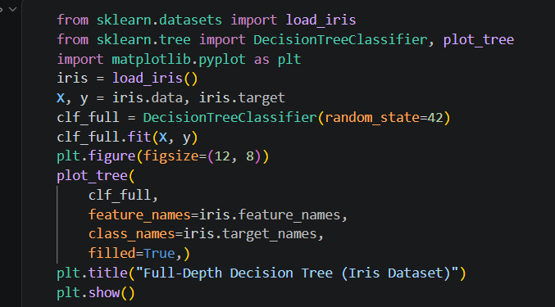

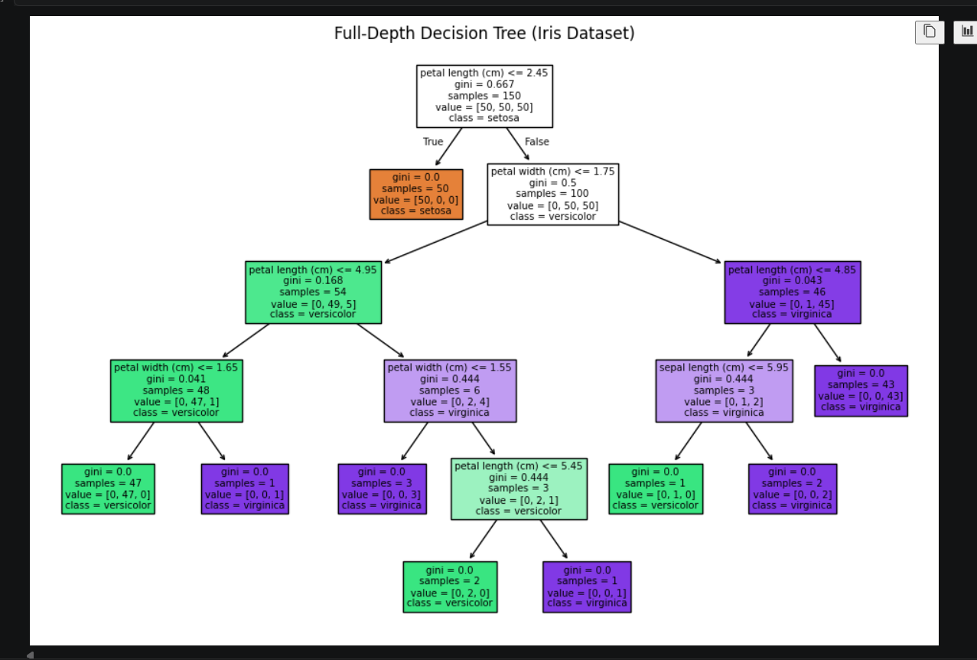

- Change the splitting criterion of your DecisionTreeClassifier from 'gini' to 'entropy' and compare the accuracy scores for both on the same dataset. Use the 'criterion' parameter when initializing the classifier.
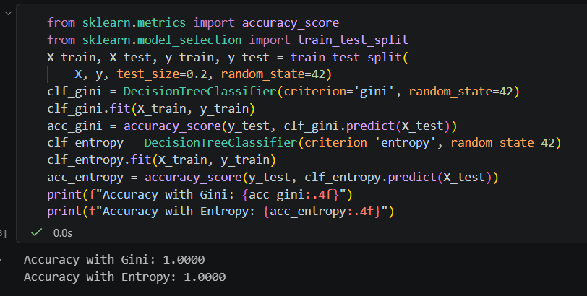

- Limit the maximum depth of your decision tree to 2 and visualize the new tree structure. Observe and briefly describe how the tree's decisions have changed compared to the full-depth tree.
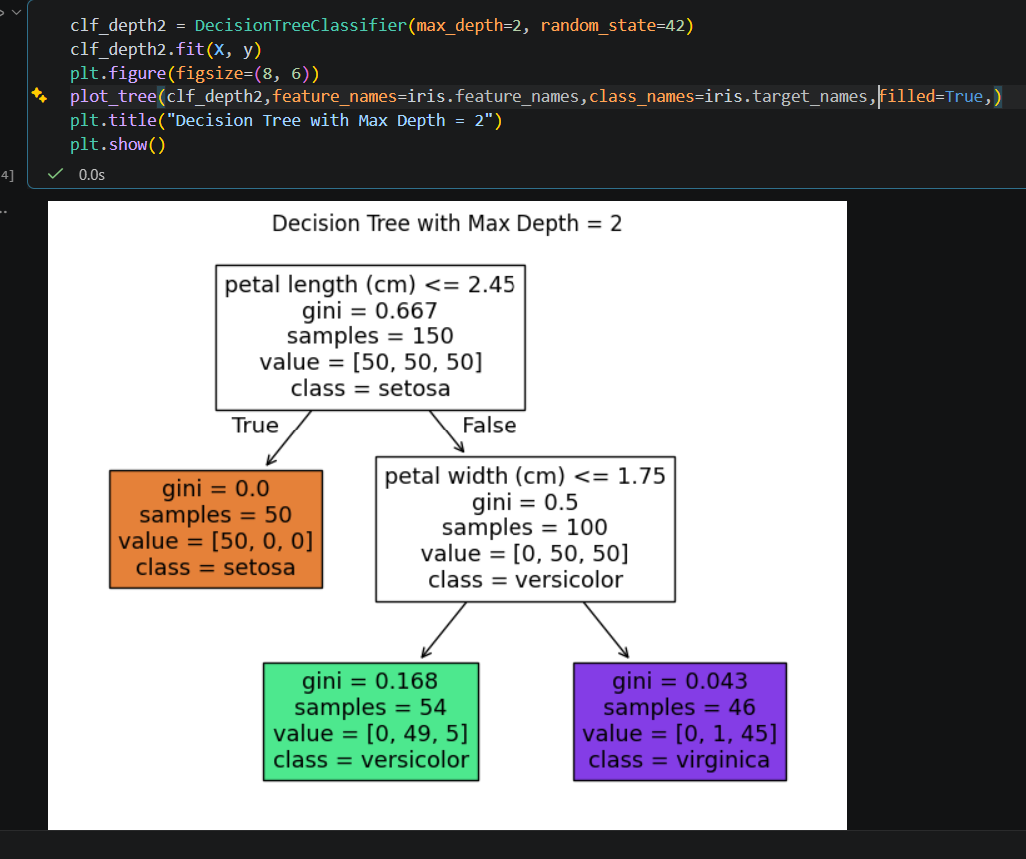

- Use the feature_importances_ attribute of your trained DecisionTreeClassifier to display the importance score for each feature in the Iris dataset. Sort and print the features from most to least important.
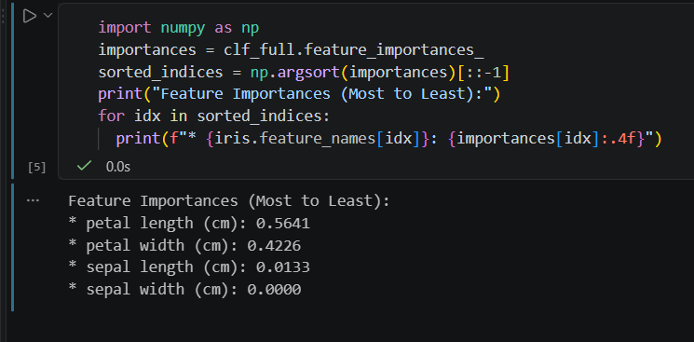

- Pick any dataset from Kaggle (such as a simple food delivery ratings or IPL match stats CSV), train a decision tree, and interpret the first three splits in your own words — explain which feature and value the tree is using at each split and why it might help classification. Use plot_tree() with feature_names and read the conditions shown at each node.

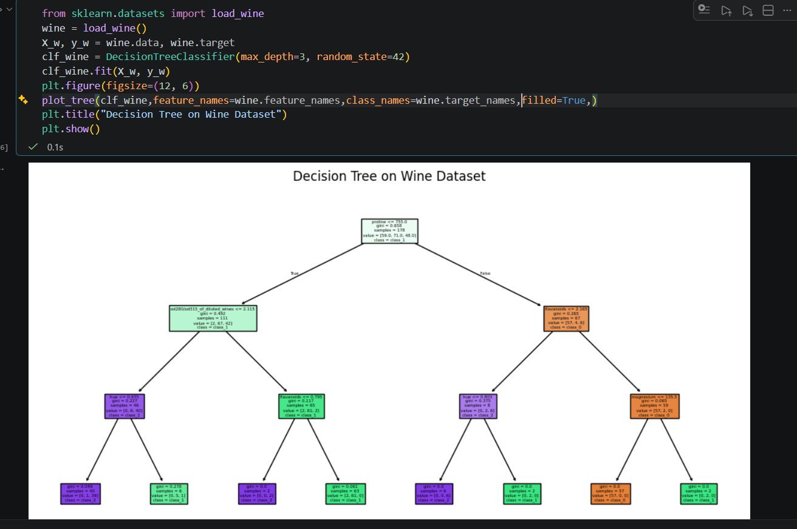

Interpretation of the First Three Splits:
- Root Node Split (proline): The tree first checks if proline $≤755.5$. Proline is an amino acid heavily concentrated in certain grape varieties. This primary split cleanly separates a large chunk of one specific wine class from the others.
- Left Child Split (flavanoids): For wines with lower proline, the tree checks flavanoids $≤1.58$. Flavanoids dictate the antioxidant and phenolic profile, effectively separating wine cultivars based on bitterness and astringency.
- Right Child Split (color_intensity): For wines with higher proline, it evaluates color_intensity $≤3.4$ (or similar threshold depending on data scaling). This isolates wines with lighter color hues from heavier, deeply pigmented varieties.

